Personal Information
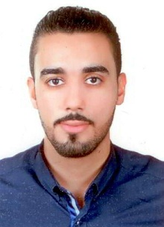
Name: Abdulla Ebrahm Khalil Ebrahm Muraidhi
Date of Birth: 14th February 1991
CPR: 910200815
Address: Villa no.: 182 Road no.: 36 Block no.: 236 - Samaheej
Telephone :( Mobile):36281081 -33766988 - 39259895
E-mail: abouod373@gmail.com

Education
Qualification Received Institute/ School Period
High School Muharraq Commercial School 2006-2009
Courses:
English course University of Pune 2011
Retailing City & Guilds of London Institute June 2013
Outdoor team building Leaders Institute for training June 2014
Cashiering Techniques Impact Essence of Learning November 2014
Business Communication Leaders Institute for training March 2015
Supervisory skills Bahrain Institute of hospitality & retail May 2015

Experience
Four years as a financial clerk in Besan Co.
Three months as a cashier in Geant.
One year as a staff in McDonalds’.
More than one year as a cashier and eight months as a Salesman in Lulu Hypermarket (Mobile Section).

Skills
- Interpersonal Skills: 1. Team Player
2. Good Communication Skills
3. Ability to deal with conflict.
4. Ability to work under pressure.
5. Decision making.

- Computer Skills: MS office.

- Languages: Fluent in both Arabic and English.

- Additional Skills: Valid Deriving license.

Interest
Playing football and car racing.

